7

Differences between two groups

Independent groups t-test in R

We shall demonstrate how to get R to run an independent t-test using the memory intervention for MS patients’ data presented in Chapter 7.1. You should load this data into R (a good way would be using Microsoft Excel). When you enter your data into the Excel file, you need to make a note of how you code up your two groups. You can use a numerical code e.g. 1 = Intervention & 2 = Control or you can type ‘Intervention’ and ‘Control’ in directly.

To run an independent samples t-test in R we use the t.test() command. For example:

> t.test(Memory ~ IntGroup)

The ~ (called a ‘tilde’) is important here as it indicates that the variable following it is a grouping variable. If you run this command, R assumes that you want the version of the t-test which assumes that you do not have equal variances across your two conditions. The t-test that you get here is called Welch’s t-test. The output using this command is presented in Screenshot 1:

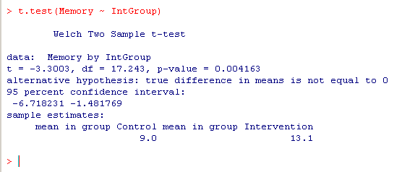
Screenshot 1
You can see from Screenshot 1 that you are presented with Welch’s two sample t-test. There is a t-value of 3.30, degrees of freedom = 17.24 and a p-value = .004163. The p-value would obviously be rounded to .004. Please also note that this is a two-tailed p-value. If you require a one-tailed p-value, you can simply halve the two-tailed value given here.

If your data meet the assumption of homogeneity of variance, you can get R to generate the standard t-test which does not have the Welch’s adjusted degrees of freedom. To obtain this, you need to add an extra argument in the brackets following the t.test() command, e.g.

> t.test(Memory~IntGroup, var.equal = TRUE)

When you use this extra argument, you get the output shown in Screenshot 2:

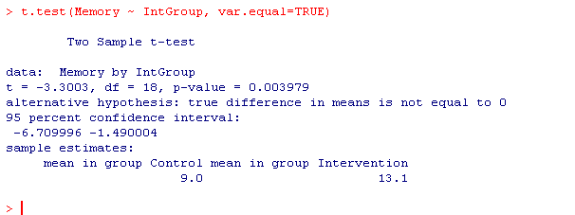
Screenshot 2
Here the t-value is the same (t = 3.00) but the degrees of freedom are slightly different (df = 18) as is the p-value (p = .003979). Again the p-value would be rounded to .004, which means that essentially we have the same p-value here using the standard t-test as we have using the Welch’s t-test.

Paired t-test in R
We use the same command to generate a paired t-test in R, but we simply add in an extra argument to the command to indicate that we want a paired t-test rather than an independent t-test. Using the chronic illness example from Screenshot 7.8 in Chapter 7, we have entered the data into R. We have to add in the paired = TRUE argument in the brackets of the t.test() command:

>t.test(VIQ, PIQ, paired = TRUE)
The first two arguments in the brackets are the two variables that you want analysed. When you use this command, you will be presented with the output shown in Screenshot 3.

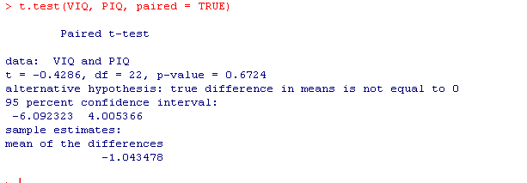
Screenshot 3

The two sample z-test is not readily available in R (perhaps because it is not a widely used test these days).

Non-parametric tests

Mann-Whitney Test in R
We can run the Mann-Whitney test in R using the wilcox.test()command. We will illustrate this here using the same data that we used to illustrate the independent t-test. The command you should type in is:

>wilcox.test(Memory~IntGroup)

As there are no other arguments presented within the brackets, R assumes that you have an independent design and will produce the Mann-Whitney statistics for you (Screenshot 4):

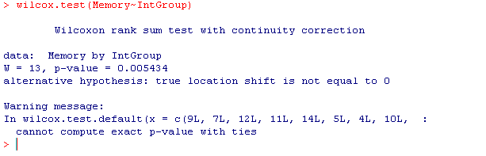
Screenshot 4

You can see here that we have a W of 13 and a p-value of .005. Thus, there is a significant difference between the groups. You should note that this is a two-tailed p-value.

You should also note that the default for R is to calculate the exact p-value. However, if there are tied scores in the data or you specify the extra argument exact = TRUE, then you will get the asymptotic p-value.

Wilcoxon signed rank test in R
To run a Wilcoxon signed rank test in R, we use again the wilcox.test() command. In this case, though, we have to add in the extra paired = TRUE argument after the variable names. To illustrate ,we will use the verbal (VIQ) and performance (PIQ) scores we used earlier to demonstrate the paired t-test. To run the test type in the following:

>wilcox.test(VIQ, PIQ, paired=TRUE)

You will be presented with the output illustrated in Screenshot 5:

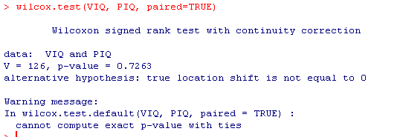
Screenshot 5
Here we can see that we have a V of 126 with an associated p-value of .73. Remember this is a two-tailed p-value. If you require a one-tailed p-value, you can simply halve the two-tailed value given here.

